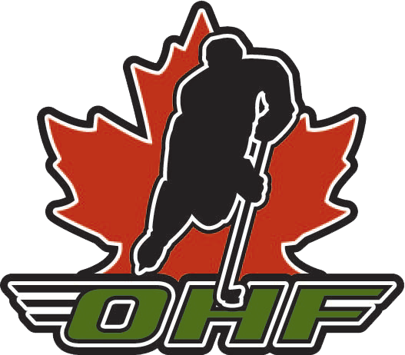

Changing Members policy
February 6, 2019

general Philosophy
  - The Ontario Hockey Federation (OHF) is made up of seven equal Members that are responsible collectively for the governance and delivery of programming to the players in partnership with the local Minor Hockey Associations, Clubs and Teams. Collectively the Members, Minor Hockey Associations, Clubs and Teams are the Stakeholders in the delivery of hockey in the OHF.
  - The OHF believes in stability within its Stakeholders as well as accountability of the Stakeholders to each other in the governance and delivery of hockey in the OHF.
  - Accordingly, where issues arise within a Member organization, these issues are best resolved internally within the Member organization, without resulting in a Minor Hockey Association, Team or Club changing Member.
  - Notwithstanding the foregoing, issues may arise from time to time that are best resolved by a Minor Hockey Association, Club or Team changing Member.
  - It is recognized that governance decisions pertaining to a change of membership can be difficult. The decision-maker must weigh among other things:
    - Any change of Member application may give rise to competing interests as between the Applicant organization, its players, the current Member, the prospective Member and their families, and other Members;
    - Any change of Member application may also give rise to potential impacts upon growing the sport within the OHF jurisdiction, retention of players within the OHF jurisdiction and best aligning the organization of hockey relative to current population densities within the OHF jurisdiction.
  - Having regard to 1.5.1 and 1.5.2 the OHF Board of Directors is best positioned to make a decision with regard to any change of Member application that best balances the competing interests in a way that reflects the organizational imperatives within the OHF jurisdiction.
  - Consistent with the foregoing, the following serves as the OHF policy/process to be applied where there is a request by a Minor Hockey Association, Club or Team to change Member.

DEFINITIONS:
  - Member: a Member of the OHF as identified at 4.1 of the OHF By-laws
  - Applicant: the Minor Hockey Association, Club or Team that applies to change from the Member to which it currently belongs to another Member.
  - Current Member: the Member to which the Applicant currently belongs but seeks to leave.
  - Prospective Member: the Member to which the Applicant seeks to belong
  - Application: the formal application submitted by the Applicant in accord with 4.3 herein.
  - Member in Good Standing: a member of a Member who is current with dues or other fees owing to the Member and who is not the subject of a disciplinary investigation, sanction or suspension by the Current Member or the OHF.
  - Notice of Amendment: the formal document required to amend By-Laws of the OHF in accordance with the OHF By-Laws.

OHF Jurisdiction
  - Any change of Member requires an amendment to the OHF By-laws and, therefore, the approval of the OHF Directors in a vote taken in accord with the OHF Constitution and By-laws.

Application process
  - The Applicant shall first, in writing, raise the issue(s) giving rise to its request for a change in Member with the Executive of the Current Member. There shall be a period of up to sixty (60) calendar days within which the Current Member shall investigate and seek an internal resolution.
  - Failing an internal resolution under 4.1, the Applicant, following a vote by its members authorizing it to proceed, may submit an application to change Member on the prescribed form. The Application shall be submitted to the Executive Director of the Current Member and to the Executive Director of the OHF at least four months in advance of the OHF Semi-Annual Meeting of Members.
  - The Application, signed by the designated signing officer of the Applicant, shall:
    - set out the reason(s) for the request;
    - attach all communications relating to the request with the Current Member;
    - attach the board minutes of the Applicant confirming the vote of its Members authorizing it to proceed with the application;
    - certify that it is currently a Member in good standing with the Current Member; and
    - outline in detail how it wishes to play/participate under the jurisdiction of the Prospective Member.
  - The Application shall be hand-delivered or sent by registered mail to both the Executive Director of the Current Member and to the Executive Director of the OHF who shall each confirm receipt within 14 calendar days. The Executive Director of the OHF shall provide a copy of the Application to the OHF Board and to the OHF Members.
    - Any Member may submit its position (with reasons) in writing within thirty (30) days of receipt of application.
  - The Current Member and the Applicant shall then engage in a formal resolution process under the supervision of the OHF. This process may extend for up to sixty (60) calendar days.
    - In the course of this process, the OHF will engage the Prospective Member and Applicant for the purpose of ascertaining if a change of Member might address the issue(s) set out in the Application and, if so, whether or not the Prospective Member would be receptive to the change in Member sought by the Applicant.
    - If the Prospective Member opposes the Application the Application will cease to proceed.
  - The Current Member and the Prospective Member shall have the option of jointly waiving any objection to the Application and, if so, shall submit a joint letter to the OHF setting out their proposed direction on the Notice of Amendment.
  - Where there is no resolution under 4.5 or where objection to the Application is not jointly waived under 4.6, the Application shall be tabled for a decision at a Board of Directors meeting prior to the OHF Semi-Annual Meeting of Members.

General Rules
  - Once the Prospective Member has been so notified under 4.2 there shall be no communication between the Prospective Member and the Applicant, except as may arise under 4.4.1.

Determination process
  - The required Notice of Amendment will be submitted by the OHF Chair of the Board upon receipt of the Application to the Board of Directors.
  - Regarding any Notice of Amendment that duly stands for determination of an Application by the OHF Board of Directors, the vote will be conducted in accord with the OHF By-Laws and the following timelines:
    - the materials will be submitted to the Members at least sixty (60) days prior to the Directors’ Meeting for comment within thirty (30) days.
    - all materials will be submitted to the Directors at least fifteen (15) days prior to the Directors’ Meeting.
    - the Applicant and Current Member will have the opportunity to present its rationale for change to the OHF Directors.
    - the decision on change of membership will be made by a majority of the OHF Directors, whose decision shall be final and binding, subject to appeal to Hockey Canada in accordance with its regulations.
  - The determination on any Application will be communicated to the Applicant and the Members through the OHF Executive Director.
  - Any application approved by the OHF Directors shall not take effect until after OHF Championship Weekend.
  - If approved, the Current Member and Prospective Member are to collaborate in good faith on a transition plan that has minimal impact on the Players, MHA’s and Leagues.

Exception
  - Notwithstanding any of the foregoing, all female teams in the province of Ontario fall under the sole jurisdiction of the OWHA and are not eligible for membership in any other OHF Member, HEO or HNO.

